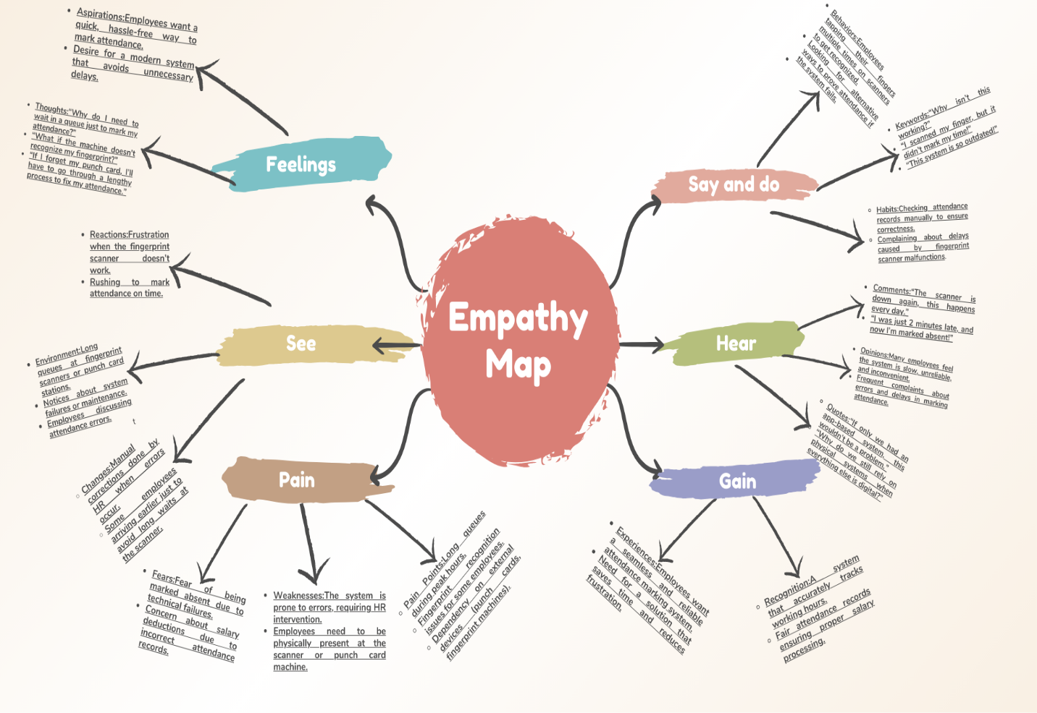

**Task Overview: Empathy Map for Attendance System…**

**1. Feelings (Aspirations & Thoughts)**

**Aspirations:**

* Employees wish for a flexible and error-free attendance marking system.
* They want a faster, automated process to avoid unnecessary delays**.**
* A system that doesn’t require physical contact (to avoid hygiene issues, especially post-pandemic).
* A solution that works from anywhere rather than requiring them to be present at a specific location**.**

**Thoughts:**

* "Why should I have to be in the office just to mark attendance?"
* "I wish the system could mark my attendance automatically when I enter the premises."
* "What if the scanner breaks down while I’m trying to log in?"
* "Why do I have to manually correct my attendance if the system fails?"
* "I hope HR doesn’t mark me absent again because of this faulty scanner!"

**2. See (Reactions, Environment & Changes)**

**Reactions:**

* Employees show frustration when their fingerprint is rejected multiple times.
* Some walk away angrily when the machine fails, while others keep retrying until it works.
* HR personnel constantly receive complaints about incorrect attendance records.

**Environment:**

* Crowded fingerprint scanners in the morning and evening.
* Employees rubbing fingers or using sanitizer before scanning to improve recognition.
* Notices on walls reminding employees to check their attendance records.
* Frequent maintenance checks on fingerprint machines.

**Changes:**

* Employees arriving earlier to ensure they log in on time.
* HR teams spending extra time resolving attendance discrepancies.
* New employees struggling to register their fingerprints properly.
* Employees hesitating to take short breaks due to fear of attendance not being logged correctly.

**3. Say and Do (Behaviors, Keywords & Habits)**

**Behaviors:**

* Employees tapping their fingers multiple times on the scanner.
* Asking colleagues for help when their fingerprint is not recognized.
* Standing in long queues to mark attendance.
* Rushing to HR if their attendance was marked incorrectly.
* Manually recording their attendance in case of machine failure.

**Keywords:**

* “This scanner is so slow!”
* “I tapped my finger three times, and it still didn’t work.”
* “Can someone check if my attendance got marked?”
* “This system seriously needs an upgrade.”
* “Not again! My fingerprint won’t scan.”

**Habits:**

* Double-checking attendance logs at the end of the day.
* Reminding others to mark attendance correctly.
* Washing or rubbing fingers before scanning for better recognition.
* Taking photos or screenshots of attendance records as proof.

**4. Hear (Comments, Opinions & Quotes)**

**Comments:**

* "The scanner is down again! This happens way too often."
* "I was literally just 1 minute late, and now I’m marked absent?!"
* "HR always takes forever to correct attendance errors."
* "Why are we still using this old system?"

**Opinions:**

* Many employees feel the system is outdated and inefficient.
* People think the fingerprint system is unreliable, leading to unnecessary stress.
* Employees prefer a more modern and flexible alternative.

**Quotes:**

* “If only we had an app-based system, we wouldn’t have to deal with these issues.”
* “Why are we still stuck with fingerprint scanners when everything else is digital?”
* “I hate wasting time fixing my attendance every month.”

**5. Pain (Fears, Weaknesses & Pain Points)**

**Fears:**

* Fear of being marked absent due to scanner malfunctions.
* Worry about salary deductions if attendance isn’t logged correctly.
* Concern about getting late warnings even when they were on time.
* Fear of losing productivity due to long attendance queues.

**Weaknesses:**

* The fingerprint scanner fails for some employees frequently.
* The system requires physical presence, causing delays.
* HR has to manually correct errors, wasting time and resources.
* No flexibility—attendance can’t be marked remotely.

**Pain Points:**

* Long waiting times at the fingerprint scanner.
* Recognition issues for employees with dry or sweaty fingers.
* Dependency on machines that often malfunction.
* Extra workload for HR to fix errors.
* Strict cut-off times leading to incorrect absences.

**6. Gain (Experiences & Recognition)**

**Experiences:**

* Employees want a seamless, stress-free attendance system.
* They prefer a mobile-based or location-based system that marks attendance automatically.
* A system that saves time instead of adding unnecessary steps.
* More accurate tracking that reduces disputes with HR.

**Recognition:**

* Employees feel valued when their attendance records are correct.
* A system that fairly tracks working hours without errors.
* No deductions in salary due to attendance mistakes.

**Conclusion:** Why the New System is Better?

The old fingerprint and punch card system created frustration due to long queues, frequent scanner failures, and HR workload for attendance corrections. The new app-based “MyAttendance” system solves these issues by:  
**1.**Marking attendance via GPS location, removing dependency on physical machines.  
**2.**Eliminating fingerprint errors, ensuring every check-in is logged correctly.  
**3.**Providing flexibility, allowing employees to mark attendance remotely.  
**4.**Reducing HR workload, as attendance records are automatically updated.  
**5.**Improving employee satisfaction, making the process seamless and stress-free.